The CSS Box Model

In CSS, the term "box model" is used when talking about design and layout.

The CSS box model is essentially a box that wraps around every HTML element. It consists of: content, padding, borders and margins. The image below illustrates the box model:

Explanation of the different parts:

* **Content** - The content of the box, where text and images appear
* **Padding** - Clears an area around the content. The padding is transparent
* **Border** - A border that goes around the padding and content
* **Margin** - Clears an area outside the border. The margin is transparent

The box model allows us to add a border around elements, and to define space between elements.

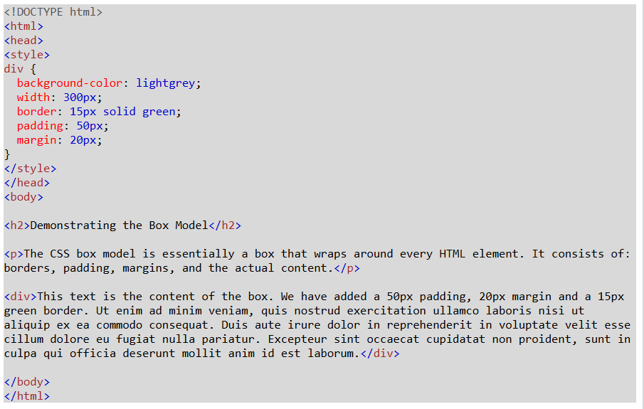

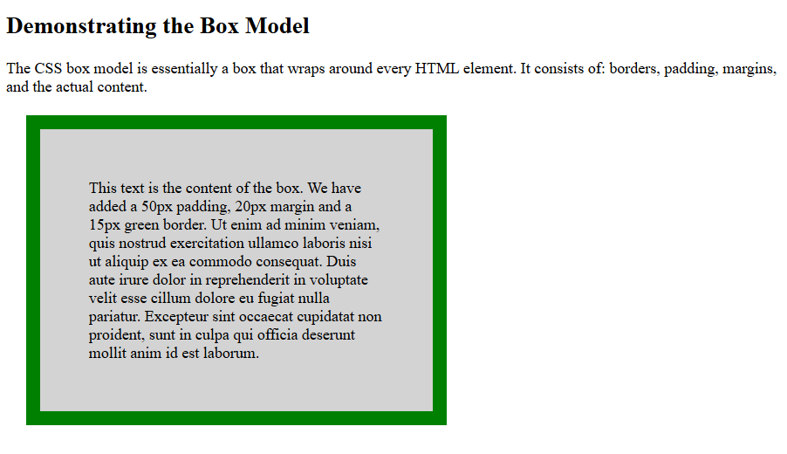

[W3Schools Tryit Editor](https://www.w3schools.com/css/tryit.asp?filename=trycss_boxmodel)

Width and Height of an Element

In order to set the width and height of an element correctly in all browsers, you need to know how the box model works.

**Important:** When you set the width and height properties of an element with CSS, you just set the width and height of the **content area**. To calculate the total width and height of an element, you must also include the padding and borders.

[Exercise v3.0](https://www.w3schools.com/css/exercise.asp?filename=exercise_boxmodel1)